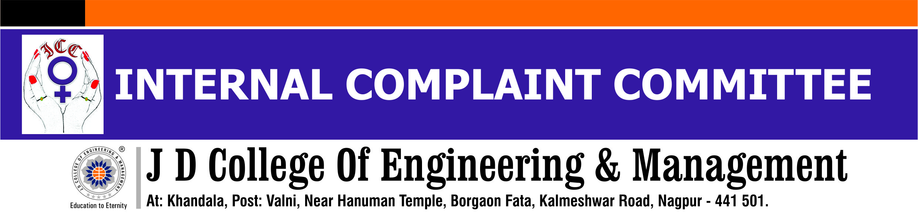
NOTICE
Date: 13/06/2025
The Hon. Supreme Court has issued the Vishakha Guidelines (2013) to prevent Sexual Harassment of Women at Workplace. To implement the above mandate, the Internal Complaint Committee has been constituted as under for the session 2025-26.
Internal Complaint Committee
Sr.No | Name of the committee member | Designation | Committee Post | Contact No
1 | Dr. Ujwala Dange | Dean(IQAC) | Presiding Officer | 9011010038
2 | Dr. Vaishnavi Dhok | HoD, EE | Member | 9766907092
3 | Ms. Sharmin Saba | HoD-ETC (Diploma) | Member | 8767926679
4 | Mrs. Aarati Mamulkar | Exam Section | Non-Teaching Member | 8767858784
5 | Mr. Mangesh Ramgirikar | Maintenance In charge | Non-Teaching Member | 9657720269
6 | Mr.Abhijit Mungate | Student, B. Tech, Vth Sem,CSE | Student Member | 9529561995
7 | Mr. Ayush Jaiswal | Student, B. Tech, Sem V AI | Student Member | 7558336293
8 | Ms. Kalyani Thakre | Student B.Tech Sem V IT | Student Member | 9623245915
9 | Ms. Utkarsha Ingle | PG student | Student Member | 9823997189
9 | Mr. Vivek Chaudhary | PG student | Student Member | 8975582196
10 | Adv. Suryakant Gajbhiye | Advocate | External Member | 9860566443
The tenure of the committee shall be of for 12 months w. e. f. 13/06/2025.All the members shall attend the meetings as per scheduled dates for effective decision making and execution.
All the above members are to take note and initiate the related responsibilities with immediate effect, upholding the purpose and sanctity of the task.

Principal
- All Deans, HoDs, SH for display and circulation amongst students and faculties.
- All the above members for NA.

