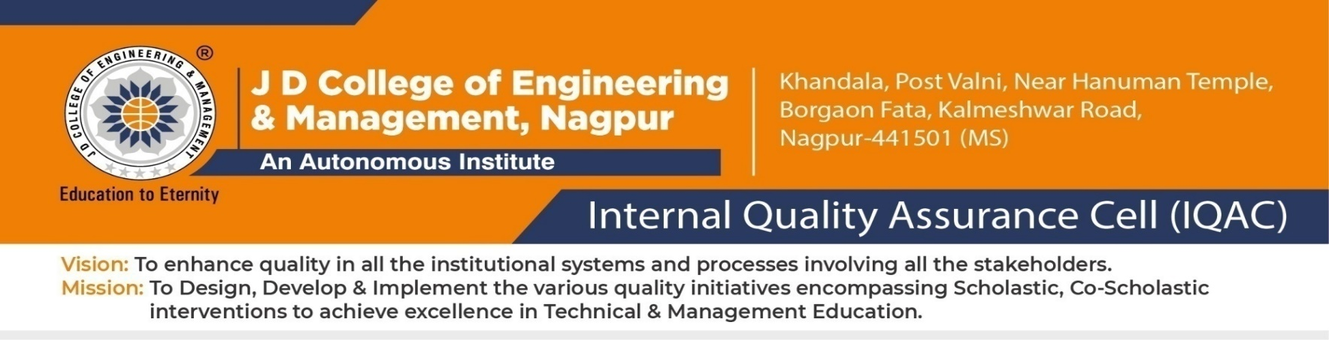
Internal Quality Assurance Cell Composition 2025-26
Date: 01/11/2025
Sr. No | Name of the committee member | Designation/Role in committee | Signature
1 | Dr. Shrikant Sonekar | Chairman
2 | Prof. S.M.Bang | Director
3 | Dr. (Mrs)Ujwala S Dange | Co-ordinator
4 | Dr. Prashant Agrawal | External peer member(Industry Expert)
5 | Mr.Rajendra Jindal | External peer member(Industry Expert)
6 | Dr.Arvind Bhagat Patil | Academic Peer member
7 | Dr.Urmila Shrawankar | Academic Peer member
8 | Dr. Sanjay Haridas | Member
9 | Dr. Pravin Kshirsagar | Member
10 | Dr.Bharat Chede | Member
11 | Dr.Amit Welekar | Member
12 | Dr.(Mrs) Shilpa Kalambe | Member
13 | Dr.(Mrs) Supriya Sawashere | Member
14 | Dr. Ashutosh Lanjewar | Member
15 | Dr.(Mrs) Atika Ingole | Member
16 | Dr. (Mrs) Parveen Shaikh | Member
17 | Mr. Mirza Baig | Member
18 | Dr. Bhavana Ilamkar | Member
19 | Mr. Rohan Kokate | Member
20 | Dr. Hemant Baitule | Member
21 | Mr. Gaurav Gohane | Member
22 | Mr. Praful Ulhe | Registrar
23 | Mr. Amit Bhattacharya | Alumni

Principal

Copy for information and necessary action:
- All the external members
- All the above members


Attendance of the meeting dated 4/11/2025
Date: 04/11/2025
Sr. No | Name of the committee member | Designation/Role in committee | Signature
1 | Dr. Shrikant Sonekar | Chairman
2 | Prof. S.M.Bang | Director
3 | Dr. (Mrs)Ujwala S Dange | Co-ordinator
4 | Dr. Prashant Agrawal | External peer member(Industry Expert)
5 | Mr.Rajendra Jindal | External peer member(Industry Expert)
6 | Dr.Arvind Bhagat Patil | Academic Peer member
7 | Dr.Urmila Shrawankar | Academic Peer member
8 | Dr. Sanjay Haridas | Member
9 | Dr. Pravin Kshirsagar | Member
10 | Dr.Bharat Chede | Member
11 | Dr.Amit Welekar | Member
12 | Dr.(Mrs) Shilpa Kalambe | Member
13 | Dr.(Mrs) Supriya Sawashere | Member
14 | Dr. Ashutosh Lanjewar | Member
15 | Dr.(Mrs) Atika Ingole | Member
16 | Dr. (Mrs) Parveen Shaikh | Member
17 | Mr. Mirza Baig | Member
18 | Dr. Bhavana Ilamkar | Member
19 | Mr. Rohan Kokate | Member
20 | Dr. Hemant Baitule | Member
21 | Mr. Gaurav Gohane | Member
22 | Mr. Praful Ulhe | Registrar
23 | Mr. Amit Bhattacharya | Alumni

